|  |  |  |  |  |
| --- | --- | --- | --- | --- |
| 5COSC021W Coursework 2 - GROUP template 2022_23  * Use this template to structure the GROUP element of coursework 2. Ensure that the correct information is in each white box. The advice for each box is basic guidance to help you focus your answer. * YOU MUST USE THIS TEMPLATE FOR THE GROUP WORK OF COURSEWORK 2. **All members of the group must submit the group template. If you don’t submit the group template you will not receive any marks for this part of the coursework**  The current size of the boxes is not indicating how much you should write; change their size as you need.When you save the file, put your name and registration number in the file name, eg ‘5COSC003W_cwk2_group_Kelly_Garret_12345678.doc’.Sections in the template that don’t have any text will receive no marks. The code files are used to ensure that what is written in the template is supported with what was implemented. However, code files only will not receive any marks and will not be used as submission of part of the template. Similarly, templates submission without the submission of code files will receive no marks.  * A reminder of plagiarism: If you use bits of another’s group report in yours or if you give your report to another group to use this will be an academic offence called ‘collusion’. * In order for the tutors to be able to assess your work you must ensure the following for your software submission:   - Submit a zipped project folder of the **COMPLETE** working project (i.e. the parts of each group member incorporated in one program, not just your part). If you have not been able to incorporate your part with that of the group, then submit only your part – it should be able to run though by itself. The folder should include all the necessary files (including databases) to run as a project on Django and SQLite.  -          Make sure that the submitted project will run using the software provided by the University. Contact your tutor if you have any problems with this.  -          Make sure that the project folder should contain all files necessary to run the program e.g. databases etc.  -          Make sure that file I/O code does not use absolute file paths.  -          Make sure that the submission contains all usernames and passwords necessary to test the program.  - Include a link to a video describing the work – each team can produce one video, but all submissions must include the link to that video. If your work is not integrated with that of the group, you can upload your own video of your work. | | | | |
| **Surname** | Uddin | | | |
| **Forename** | Imadh | | | |
| **Registration No:** | W1910647 | | | |
| **By submitting this coursework you agree to the following:** | | | | |
| I confirm that I understand what plagiarism is and have read and understood the section on Assessment Offences in the Essential Information for Students. The work that I have submitted is entirely my own. Any work from other authors is duly referenced and acknowledged. | | I confirm | | |
| **List here the team name and the other members of your group** | Group E-  Wasim Ullah (w1895877)  Imadh Uddin (w1910647)  James Price (w1827690)  Tsz Fong Chan (W1819419) | | | |
| **Details for testing** | http://127.0.0.1:8000/login/  Admin acc Login:  imadhuddin  zeVper-quxzej-2xuqvi | | | |
| **VIDEO DEMO** | <https://universityofwestminster-my.sharepoint.com/:v:/g/personal/w1910647_westminster_ac_uk/EUn_Y0X7viVMlBkqdOcONzUBPsqCJ81CHRugqGWAEoqEQg> | | | |
| Code functionality – Database implementation (10 marks) | | | |
| **Which group members worked on this:** Indicate the name(s) of the section leader(s), as well as all contributors, in writing the text in this template. Note the type of contribution (eg writing a part, providing feedback, reviewing final version).Group members that have neither led nor contributed will not receive any marks for this section. | | | |
| James price (section leader) – created equipment tables and associated crud functions.  Tsz Fong Chan (section leader) – created the db.sqlite3 database, where are used to store all the data in this database, which included the registration_user table, used for saving the id, account_id, and password of the registered user.  Imadh Uddin(section leader) – created booking/reservation tables and associated functions.  Wasim Ullah – supported in meetings with suggestions for categories and helped review/finalise structure. | | |
| **Guidance:**   * Describe here the tables (entities, attributes, CRUD operations) that you implemented for the databases | | | |
| The main two tables implemented for the database were focused on the user or admins functional needs. The tables made were equipment lists that are available to manage/book etc. and information necessary for reservation/booking. Main entities were Item and Bookings. The equipment database is the larger in comparison with the others, it is comprised of one main section and some smaller ones for sections that may have needed expansion or more control like item type and status. The main section of it holds most of the information with the other smaller tables connecting to it with foreign keys, examples of attributes were serial number, name, type(foreign key), CPU, GPU, RAM, status(foreign key), onsite, audit, quantity, item inventory location, date out, date return, description, comments, warranty and user(foreign key). The booking functionality is run off two tables booking and booking forms. These tables contain the information for the reservation inputs like start/end time and date and attributes to mark items as overdue along with foreign keys to connect them to the Item tables.    Functionality attached to the tables in the database in the form of CRUD operations was implemented for the Item tables allowing for creation, deletion and the ability to update the info as well as display/read everything relevant for the tables in the database allowing both admin and normal user the functionality that was relevant to them. While working to create these tables the main goal was to try keeping them as accurate as possible and adapting them with this logic when needed as we moved through the project.  Django comes with Built-in user model which is what we chose to use for handling users. attributes for user management within Django include username, email address, and password, are given by the User model in Django's django.contrib.auth.models. This obtains the user data required for identification and authentication. The implementation of CRUD operations (Create, Read, Update, Delete) allows developers to work with user data using Django's ORM. The User Model supports the following functions to manage user permissions and access levels: "is_active," "is_staff," and "is_superuser." user management became much easier using built-in capabilities, such as password validation, also guarantee security. Because of this, the User model in Django gives us a easy reliable way for authorising and authenticating users.  Imadh Uddin:  The Booking model establishes the representation of the booking entity in the database. It has a few attributes with references to other entities, for instance, Item and User. Each booking record is bound to exactly one of the items to be booked and to a user that made a booking. The model includes the start and end dates and times, hence making the timeframe per booking. the model attributes also contain a boolean field, is_overdue, to note if a booking goes beyond its scheduled end time. Such attributes so defined in the model further help in the storage and retrieval of information about the booking such that one can perform typical CRUD operations such as create, read, update, and delete of booking records. One example of where this is used is when generating reports for overdue equipment  The BookingForm class is an interface to interact with the data related to bookings, being input by the user. This form is actually a subclass of Django's ModelForm, which structures the methods required to deal with form data related to bookings. In this form, the user can select the start_date start_time end_date and end_time of bookings. There's a checkbox field which is used to represent the bookings for the items that are overdue, this isnt visible or accessible to the regular users and only admins can mark overdue equipment. The checkbox is ticked by admins when a booking is overdue, this would turn the boolean field to “true”. Admins can also create a booking of an equipment for other users whereas regular users can only book equipment for themselves. This form takes in all the logic of validation and processing of information submitted by users about booking. For the creation and updating of booking records, it is provided that users must submit for details. It allows users to be able to interact with the booking system, resulting in the creation or updating of booking records.  Both Booking model and BookingForm class together serve as the core of the booking system within the Django application. The structure and functionalities are provided to save, retrieve, update, and delete booking records, which now lets users to keep their bookings correctly structured, and data is safely kept in the database in a way thats organised. | | | |
| Application frond end– group part (10 marks)(if you have not been able to incorporate your work in the group project do not fill in this section, instead fill in section 2a below) | | | | |
| **Which group members worked on this:** Indicate the name(s) of the section leader(s), as well as all contributors. Note the type of contribution – eg wrote part of the text, provided feedback, proofreading etcGroup members that have neither led nor contributed will not receive any marks for this section. | | | | |
| Imadh Uddin- worked on the front end of view equipment, current bookings, Historical bookings, Booking Management, User Management, Equipment Management, the relevant forms of those pages and also helped with report generationTsz Fong Chan – Worked on the front end of login, register, profile management and changed the password page.   Wasim Ullah - Worked on report generation and helped with booking management. | | | | |
| **Guidance:** Attach here a screenshot of the front end of your application, incorporating the elements from each group member.   * Discuss here the main UI/UX principles you applied in your implementation. Discuss whether the UI/UX experience is consistent across the pages of the applications. Support your text with examples from your implementation and reflect on the final front end submission. Eg what you feel provides good user experience and why; what would enhance user experience. * Marking of this section will also include the defence of your work during the demonstration as well as review of the application through the video. * Use as many pages as required | | | | |

Imadh Uddin:

The UI consists of mainly white, blue, and dark grey for the content to be delivered. The background is coloured white, giving a very clean and roomy canvas that laid out the content. Aesthetically placed blue always enhances the confidence and engagement of the user as it stands for trust and professionalism. Proper contrast and intuitive navigation through the UI are provided with the navigation options in white text and very dark grey in the sidebar. The combination of these colours creates a harmonised and welcoming user interface, which in general works in unison with colour psychology to incite positive feelings and behaviours. All the buttons have been designed and laid out coherently for effective user interaction and navigation.

Operations like delete or cancel are styled in red to represent critical actions and attract just the right amount of immediate attention to options that potentially may be irreversible, causing the user to be more cautious as the red is forcing a choice to deter unintentional deletions. Other actions will be in blue as they are user-oriented. Creates a safe and trusted feeling in the interaction. The constant usage of colour enhances the application UI to be intuitive, thus users can navigate their way around with ease giving them a pleasant user experience when they are navigating through the application in regard to the potential range of types of action so that it's easy to go around the app with the least risk of making errors as possible.

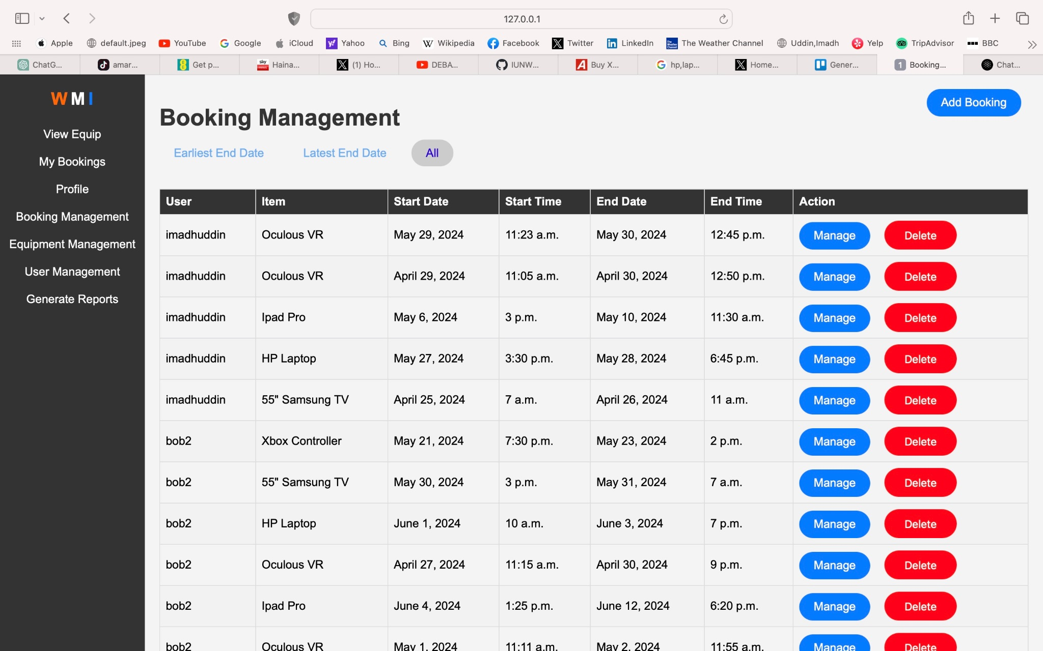

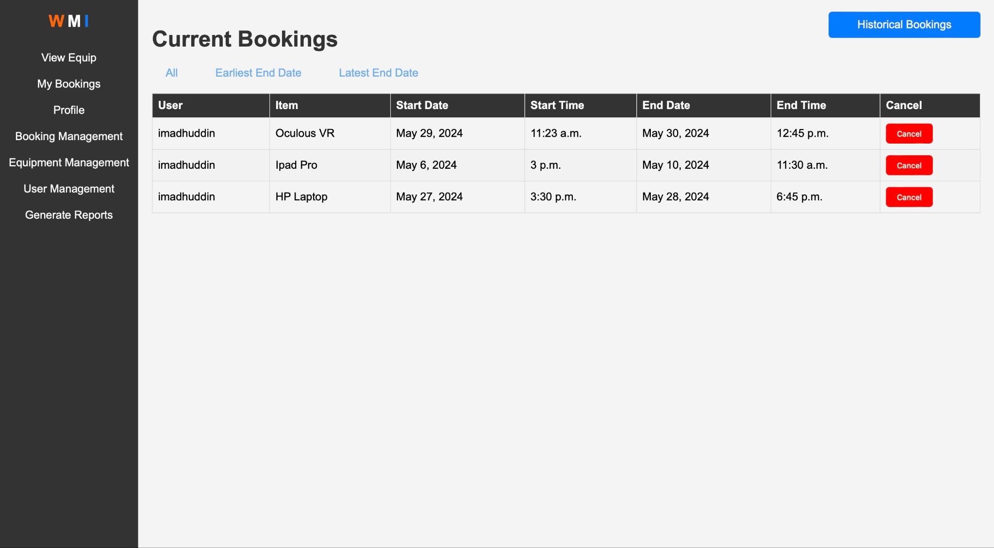

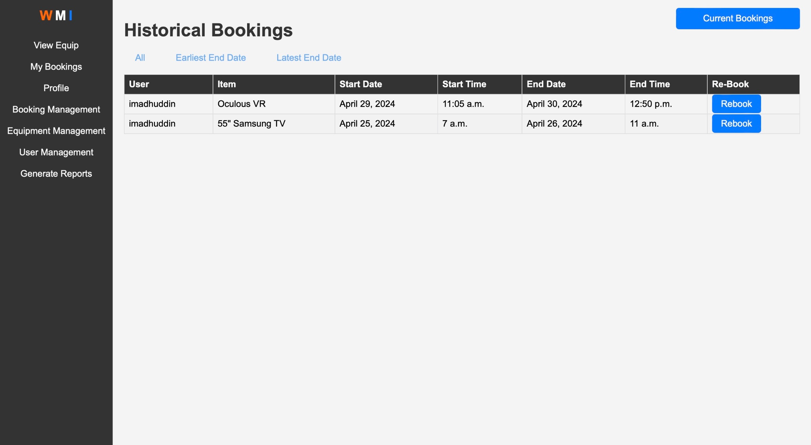

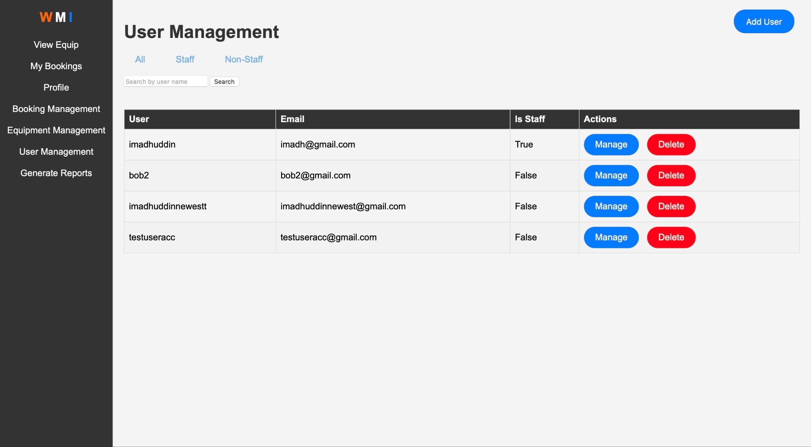

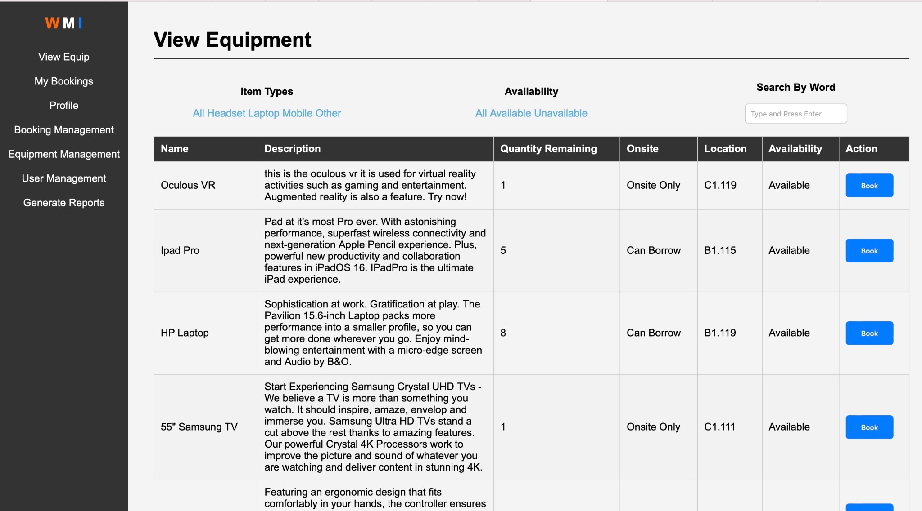

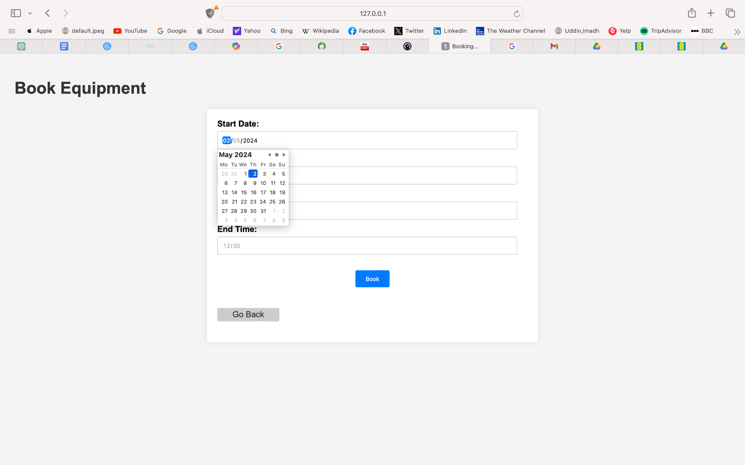

Tsz Fong Chan:

The main principle I have used is simplicity with enough functionality creates the best efficiency. In my design for UI/UX, it is easy to use, with common design like all other login systems in the world nowadays, it is straightforward, simple, and not confusing at all.

From my screen shot, as you can see, all the fields contain some hints on what the fields want, which gives high readability, and they are self-explanatory. With simple layout and design, this can bring full useful information to the user.

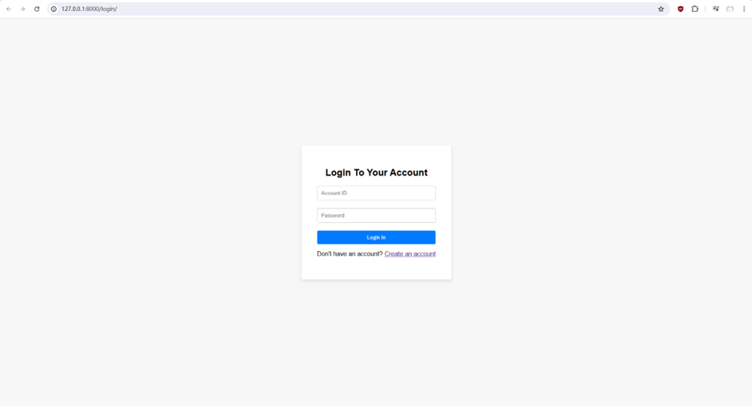

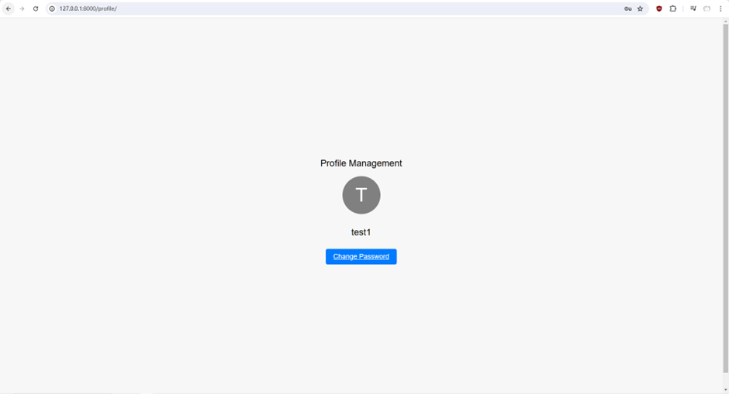

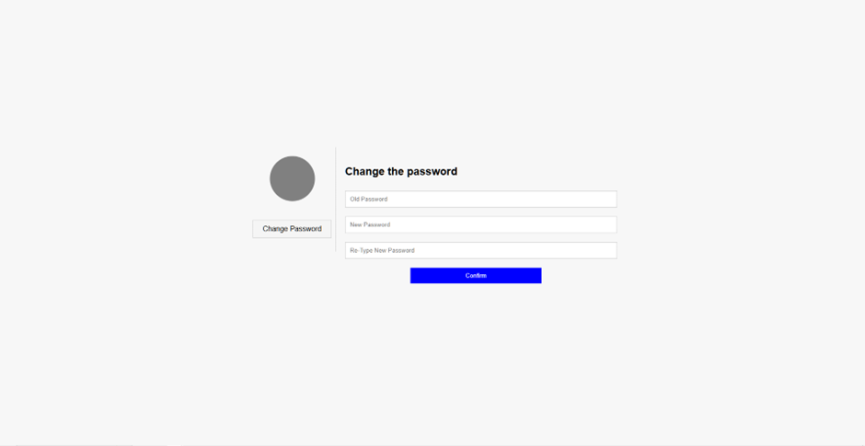

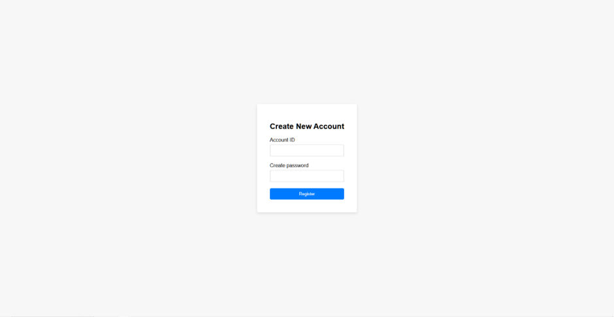

Wasim Ullah:

The screenshots provided below show the UI which has a consistent colour scheme across all pages of the application with a strong contrast ratio to the text. This makes it accessible for everyone including those with low vision as it is easy to read. The layout of the page remains consistent such as the navigation bar which allows the user to be familiar with navigating around the website smoothly. It was vital to keep clickable buttons as blue as not only does it contrast well with the white and grey background, it is normally distinguished as a hyperlink which means users are familiarised with blue buttons/text being clickable elements. For each report generated, the information and layout on the UI is displayed the same in each layout as users are able to interpret the reports much quicker with a familiarised layout. The text “Back to reports” is blue as its common for clickable elements to be blue, which allows the user to understand that to go back to the previous page they click on the text helping the user have a smooth experience of the application.

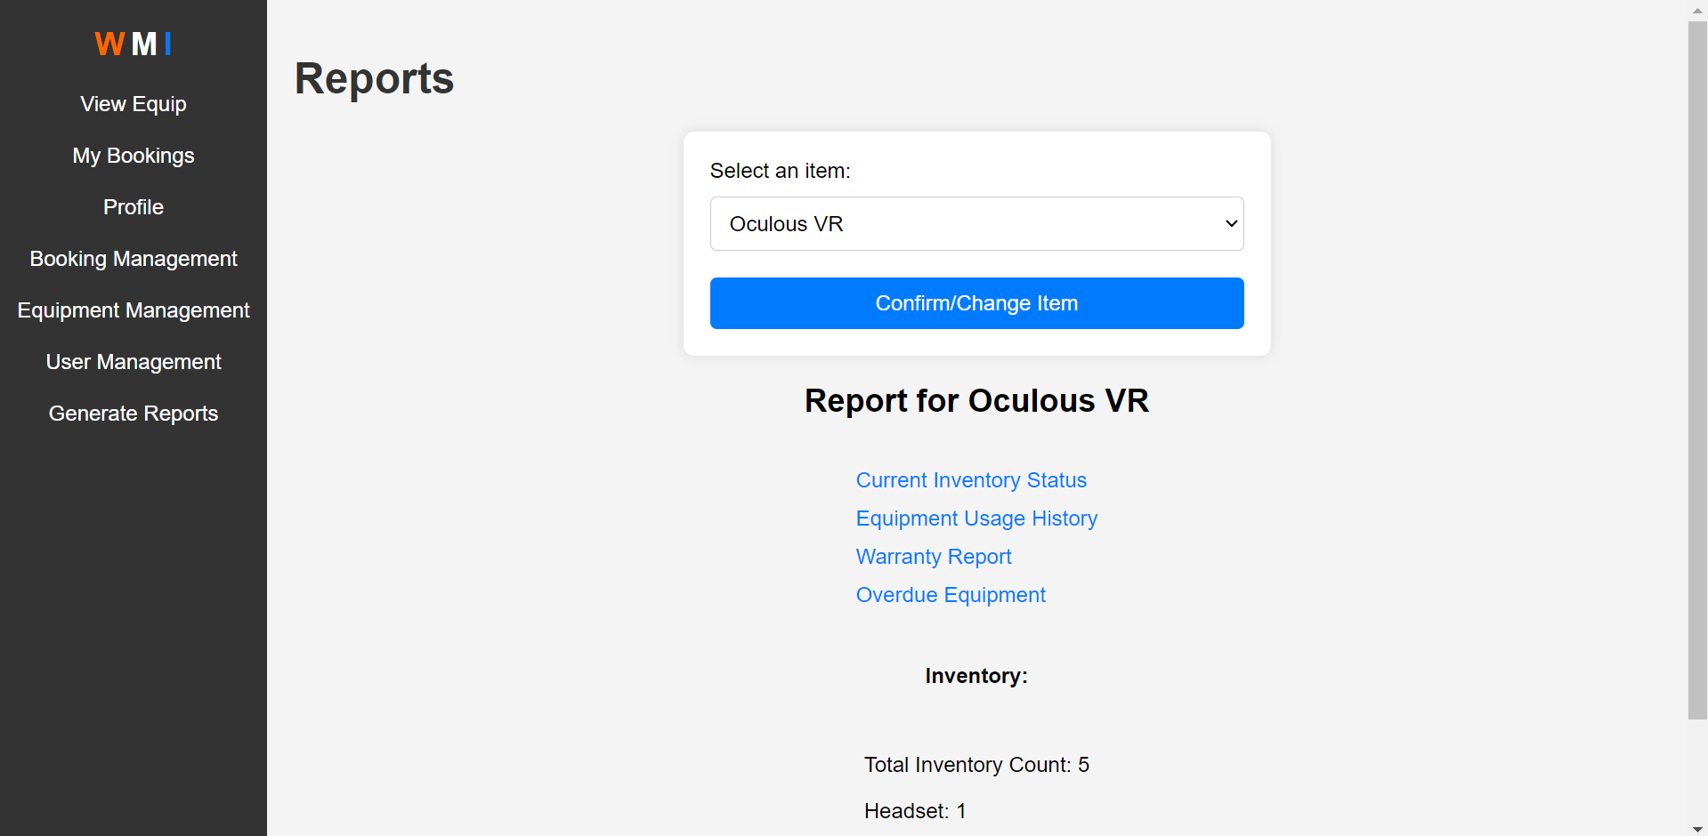

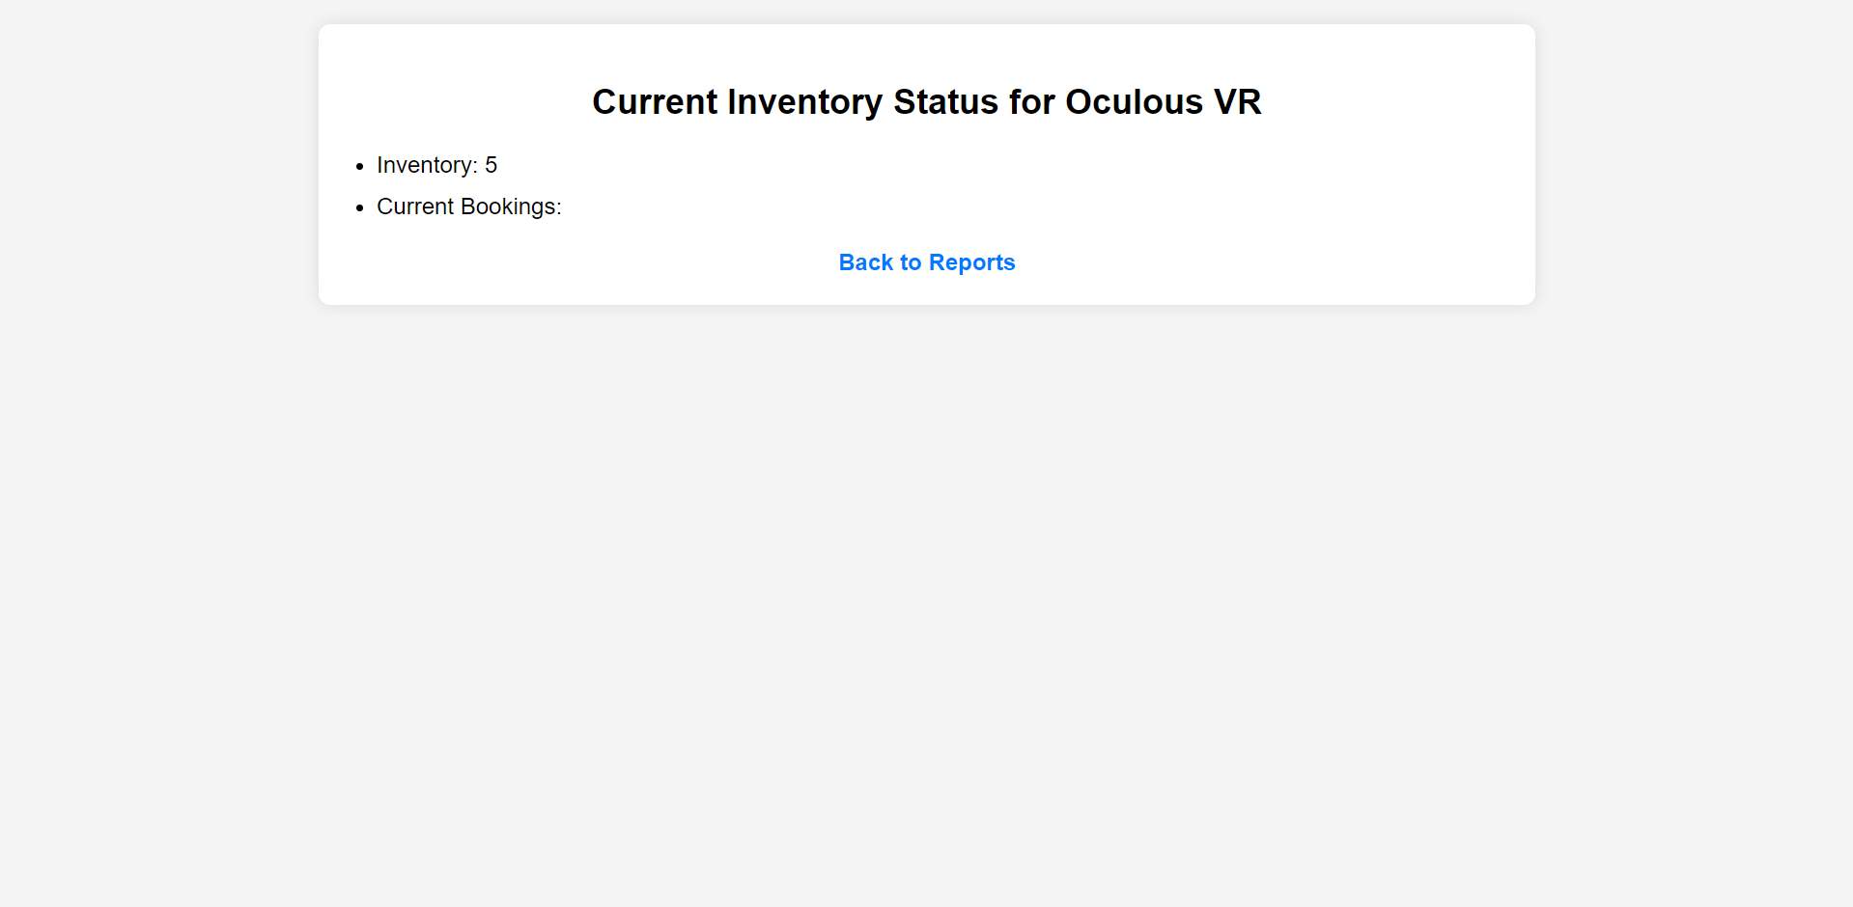

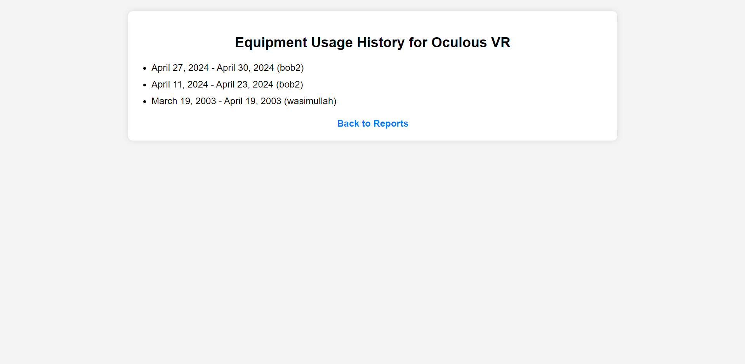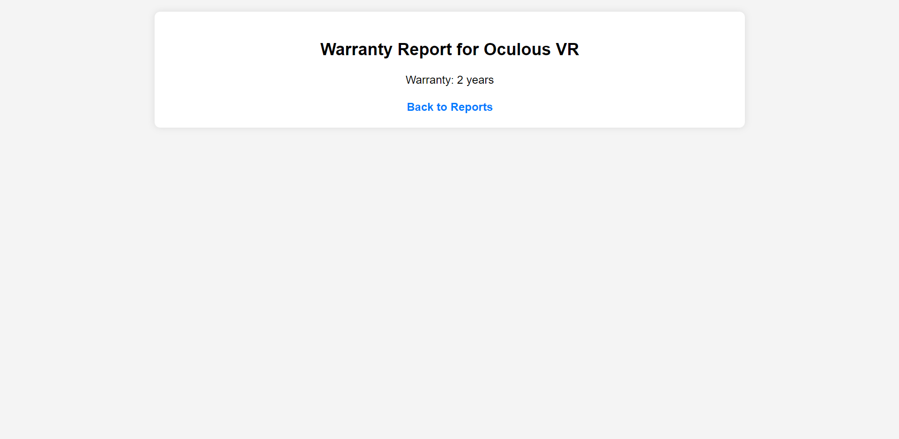

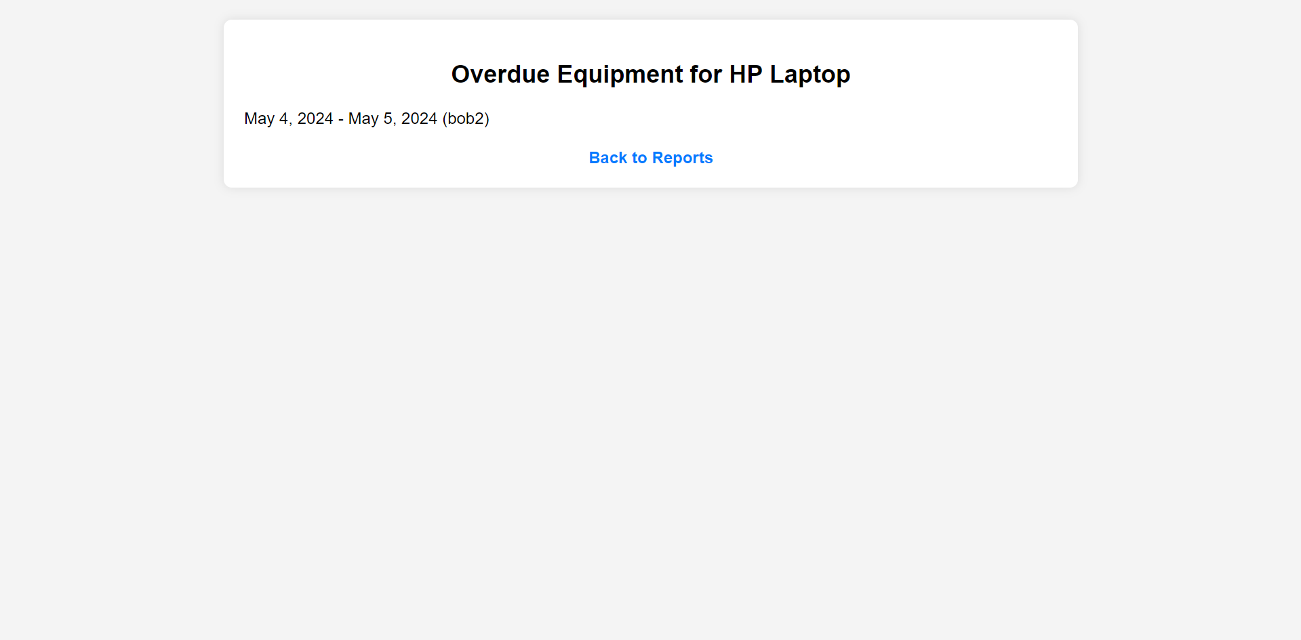

|  |
| --- |
| **2a. (only if you cannot fill in part 2 above)****Application Front End (HCI) – individual part** |
| If you have not been able to connect your part to the group application:   * Attach here a screenshot of the front end of your own implemented part. * Explain why your part has not been able to connect to the group application. * Sum up the main UI/UX principles applied in your implementation (10 marks) and reflect on the UI/UX implementation by discussing good elements, why you believe they provide good UI/UX (with examples), and what changes can be made to improve it? * Marking of this section will also include the defence of your work during the demonstration |
|  |

|  |
| --- |
| Application Front End (SECURITY)– group part (10 marks) |
| **Which group members worked on this:** Indicate the name(s) of the section leader(s), as well as all contributors. Note the type of contribution – eg provided references, wrote text, provided feedback, proof reading etc Group members that have neither led nor contributed will not receive any marks for this section. |
| Imadh Uddin: designed the front end in a way where admin features are ONLY visible to staff and also implemented robust authentication and authorization mechanisms  Wasim Ullah: helped with the implementation of authentication and authorisation mechanism. |
| Guidance:   * Sum up all the main security issues of the application and how they were addressed   and any security risks still remaining   * Marking of this section will also include the defence of your work during the demonstration |
| Imadh Uddin: One Security issue which was present was the fact that there was no differentiation between the access permissions of a regular user and an Admin user. At first inorder to handle the issue I decided to just place if statements within the html pages so that the navigation options that are admin specific would only be visible if the user is signed in as admin. However there was a major loophole with this method as this was only masking the problem rather than solving it since any regular user can type the URL path and be taken to the admin only pages. To solve this Issue i implemented robust authentication and authorization mechanisms. The functions in view.py which should only be accessible to admins now have @user_passes_test(user_is_staff) decorators, for this to work i defined a user_is_staff function first. For each view that has @user_passes_test(user_is_staff), regular users will not be able to simply enter the URL and gain access to the admin features in which the main purpose is Database Management.  Tsz Fong Chan: Worked on the login security, firstly the encoded characters for typed password, so anyone around it can not see the actual password the user type. Secondly, the submission method has been “post” to the backend, and this has created good security. Thirdly, I have purposely designed the password security by the database only store the encrypted password with SHA256, by that, even admin checking in the backend, admin cannot see the actual password of any user due to the matching mechanism. Let say the user has a password of “helloword123”, and the encrypted string of the “helloworld123” is “asdrsdgasd1241”, so “asdrsdgasd1241” will get store in the database, so when any new login with the same ID has entered the password, and let say if that password is “helloworld321”, and the encrypted string is “gtaset351”, and it is not match with the “asdrsdgasd1241” in the database, and therefore that is not the correct password. With all that security, there are one security risk I can think of is the brute force for cracking the password matching mechanism, however with SHA256, the possibility to able to crack the code with brute force is very low but never zero, therefore it can potentially be a risk but can be ignore in some extent. |

|  |
| --- |
| Professional conduct: Legal & Ethical (10 marks) **4.1 Legal** |
| **Which group members worked on this:** Indicate the name(s) of the section leader(s), as well as all contributors. Note the type of contribution – eg provided references, wrote text, provided feedback, proof reading etcGroup members that have neither led nor contributed will not receive any marks for this section. |
| James Price - Created and referenced list for legal Issues  Imadh Uddin- provided constructive feedback and proof read |
| **Guidance:** List here the legal issues that would affect both the development and the use of your application. You need to support this work with research and cite your sources within the text. The marks in this section also include marks for references (see end of document). |
| Security is one of the main concerns regarding the project. Maintaining security for information as a whole for malicious and non-malicious outside sources Impacts the way that information is stored and accessed throughout the application. Ensuring that nothing is openly available without verification helps to keep issues with security under control. “With the increasing prevalence of cyber threats, compliance with cybersecurity laws and regulations is more important than ever for software developers”(Pulsion, 2024).  Regulations also affect the development and use of the application making sure that rules and laws have been followed in respect to collection and management of data.  “ Non-compliance leads to penalties and reputational damage, highlighting the need for integrating legal considerations”(codium, 2023).  Privacy and confidentiality within the app is another major concern. Making sure that information is not incorrectly shared amongst anyone is important to the functionality of the finished product in terms of protecting sensitive data that should only be available to people with specific roles. “Controlling confidentiality is, in large part, about controlling who has access to data. Ensuring that access is only authorised and granted to those who have a "need to know" goes a long way in limiting unnecessary exposure”(Secure UD) |

|  |
| --- |
| Professional conduct – Legal & Ethical4.2 Ethical |
| **Which group members worked on this:** Indicate the name(s) of the section leader(s), as well as all contributors. Note the type of contribution – eg provided references, wrote text, provided feedback, proof reading etcGroup members that have neither led nor contributed will not receive any marks for this section. |
| Wasim Ullah - Wrote the text of accessibility, the issues and affects to the application.  Imadh Uddin- Wrote text on importance of transparency for legal and ethical considerations. |
| **Guidance:** With the aid of a table list here the ethical issues that would affect both the development and the use of your application. You need to support this work with research and cite your sources within the text. The marks in this section also include marks for references (see end of document). |
| |  |  |  | | --- | --- | --- | | **Issue** | **Affect** | **References** | | Inaccessible to everyone | Accessibility to our application is important because if it fails to accommodate users to access the application, it can cause damage to the reputation of the application. users with disabilities or poor internet connection and devices are affected and preventions to access the website may cause users to deter from the site which will cause a loss of engagement. | Services, F.I. (2023) *The ethical considerations of website accessibility*, *LinkedIn*. Available at: https://www.linkedin.com/pulswebsite-accessibility/ | | Lack of transparency in the application | Without the knowledge of the user, data mining in the application violates the users privacy which affects the development of the application. Without privacy policies in the application there is a lack of transparency that affects the users trust. This will damage the reputation of the application. | Barger., R.N. (2008) *Computer ethics [electronic resource] : a case-based approach / Robert N. Barger.* Cambridge: Cambridge University Press. | |  |  |  | |  |  |  | |  |  |  | |  |  |  | |  |  |  | |  |  |  | |  |  |  | |  |  |  | |  |  |  | |  |  |  | |  |  |  | |  |  |  | |  |  |  | |
| References (marks included in each of the main sections) |
| Section 4 must be supported by research.List below your sources, using Harvard referencing. Make sure that your references are referred to correctly from the relevant text of your work. **If you are not clear how to reference read:**  **https://www.westminster.ac.uk/library-and-it/support-and-study-skills/guides-and-tutorials/referencing-your-work** Here’s how we’ll assess it:  * No research sources: that’s very bad for level 5 work * There is one source with all information, copied directly as if it’s your own text: that is plagiarism * There is one source with all information, referenced and discussed: that is bad research * There are a few different sources, referenced and discussed in the text: this is getting better * There are quite a few good sources from many different places, referenced and discussed in the text: this gets good marks. |
| **Section 4.1 references** |
| Pulsion.co.uk (2024) *Ten legal issues in software development*, *Business Law Donut*. Available at: https://www.lawdonut.co.uk/business/blog/24/01/ten-legal-issues-software-development (Accessed: 02 May 2024).  *Legal compliance in software engineering* (2023) *CodiumAI*. Available at: https://www.codium.ai/developers-hub/legal-compliance-in-software-engineering/ (Accessed: 02 May 2024).  Secure UD (no date) *Managing data confidentiality*. Available at: https://www1.udel.edu/security/data/confidentiality.html (Accessed: 02 May 2024). |
| **Section 4.2 references** |
| Scott, A. (no date) *Ethical web development*, *Ethical Web Development*. Available at: https://www.ethicalweb.org/ (Accessed: 02 May 2024).  Barger., R.N. (2008) *Computer ethics [electronic resource] : a case-based approach / Robert N. Barger.* Cambridge: Cambridge University Press.  Services, F.I. (2023) *The ethical considerations of website accessibility*, *LinkedIn*. Available at: https://www.linkedin.com/pulswebsite-accessibility/ |